Computational Physics HW4b: Damped Driven Pendulums and Nonlinear Pendulums

1. Show that the leapfrog algorithm for computing the evolution in angular velocity is given by the following equation:

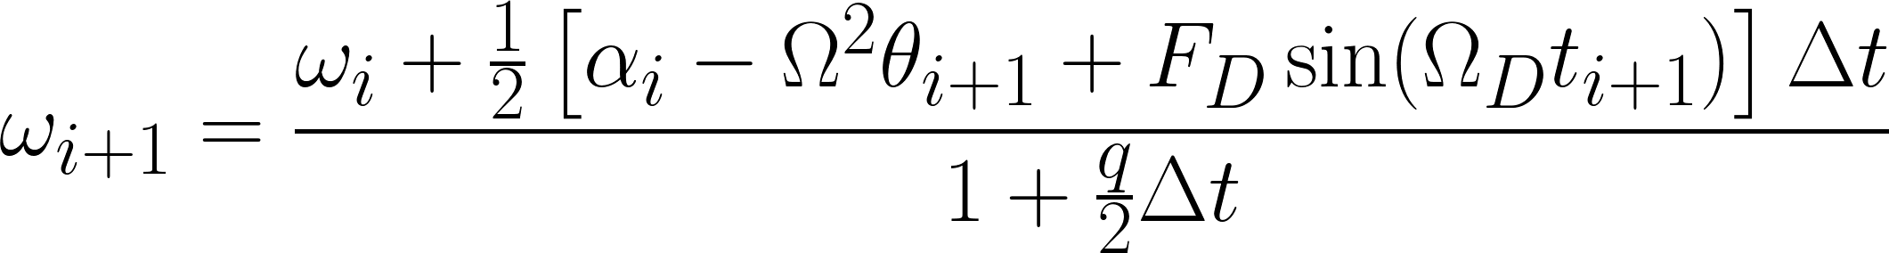

1. Write a program to solve the damped, driven pendulum using the leapfrog algorithm. You may assume an initial condition of angular velocity is zero but be prepared to do the general case in HW 4c.
2. Show evidence that the numerical solution to the underdamped non-driven pendulum matches the analytical solution.
3. Show evidence that the numerical solution to the critically damped non-driven pendulum matches the analytical solution.
4. Show evidence that the numerical solution to the over damped non-driven pendulum matches the analytical solution.
5. Construct plots for angular position vs. time for each of the three cases.
6. Construct phase space diagrams for each of the three cases (what should go on the y-axis in this case?).
7. What conclusions can be drawn about the energy of the pendulum in each of the three cases? What other conclusions can you make? Discuss.
8. Now include a driving force.
9. For each of the three cases construct: plot of angular position vs. time and phase space diagram.
10. For each of the three cases construct a plot of amplitude vs. driving angular frequency/natural frequency. Where does the maximum occur?
11. In the plots constructed in #10, what effect if any does q have on the peak and width of the curve? Explain why using physics.
12. ~~For each of the three cases construct a plot of phase lag (the difference in phase between the angular position and the driving force) vs. amplitude. What conclusions can be drawn? Explain.~~
13. Write a program to solve the nonlinear pendulum with no damping and no driving force using the leapfrog algorithm.
14. Construct a plot of angular position vs. time graph using a small angular displacement as the initial condition. Compare the results to the linearized (SHO) case. Explain your findings.
15. Construct a plot of angular position vs. time graph using a large angular displacement as the initial condition. Compare the results to the linearized (SHO) case. Explain your findings.
16. For large initial angular displacement, construct a plot of period vs. amplitude. What should the plot be in the linearized case? Compare the two and explain how they are different and why.